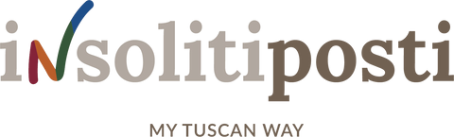

FARMHOUSE EXPERIENCE

“Mungi e Mangia”Farm!
TOUR AND TASTING
This experience includes a guided tour on a dairy farm to learn about the processing of the cheese produced by the company, a guided visit to the barn to see the goats and finally a cheese tasting together with a tasting of our 3 types of wine, extra- virgin olive oil, jam/ honey and our vegetables pickled in oil.

PRICE PER PERSON:
40 EUROS (adults)
25 EUROS (children-3-11 of age)
Duration: about 2 hours

GOATS EXPERIENCE
A whole afternoon with a few goats and their care. We will arrive at about 3.30 p.m., and we will visit the cheese farm and work in the stable where you will place hay in the manger and milk the goats; the experience takes about 2/3 hours. The experience ends with a tasting of our cheese along with a tasting of our wines, jam, olive oil and more.

PRICE PER PERSON:
80 EUROS (adults)
50 EUROS (children-3-11 of age)

CHEESE EXPERIENCE
This new experience we want to offer our customers-for groups composed of maximum 6/8 people- takes place on a dairy farm. Our guests will process milk. The arrival time should be about 8.30/9.00 a.m. You will be engaged in processing primosale cheese and ricotta cheese, which you will taste during the final tasting or you will bring home; you will visit the stable to get to know the goats. Tasting /brunch will take place at the end of the experience.
process a

PRICE PER PERSON:
180 EUROS (adults)
90 EUROS (children-3-11 of age)

Booking information
Argonauta Viaggi Empoli di Robintur Gattinoni Spa
Via R. Sanzio 199 – 50053 Empoli
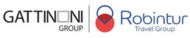
+39 057183402 - insolitiposti@robintur.it www.robintur.it

